The Chronicle of Higher Education

After DEI Ban, UT-Austin Eliminates a Division and Lays Off Its Former Diversity Staff
By Katherine Mangan
APRIL 2, 2024
ILLUSTRATION BY THE CHRONICLE; ISTOCK
The University of Texas at Austin announced on Tuesday that it was closing its Division of Campus and Community Engagement and laying off an unspecified number of people who had been working in DEI-related roles. In a joint news release, the Texas chapters of the American Association of University Professors and the NAACP said that at least 60 people were losing their jobs, about 40 in the division alone.
“Some have received these pink slips even though they have received assignments and are no longer working in DEI-designated jobs,” the statement said. Most of the layoffs are expected to take effect over the next three months.
The layoffs were announced a week after state Sen. Brandon Creighton, the Republican sponsor of Senate Bill 17, notified public colleges that they had until May 3 to submit statements describing how they were complying with specific requirements of the law. Those include eliminating all diversity, equity, and inclusion offices and officers, ending all diversity training, and banning any preferences based on race, sex, color, ethnicity, or national origin.
The job cuts include all three full-time staff members at the university’s Women’s Community Center, according to a source at the university who spoke to The Chronicle and asked not to be identified. Her job ends on July 5, and she said she didn’t want to risk losing her position and benefits before then. The center that will be closing had already been significantly overhauled to comply with SB 17, one of the nation’s most stringent anti-DEI laws.
ADVERTISEMENT
News of the dismissals came as the university’s president, Jay Hartzell, announced in a campuswide email that the flagship would be closing the Division of Campus and Community Engagement and distributing most of its programs to other divisions. The Women’s Community Center had been part of that division.

DEI legislation tracker
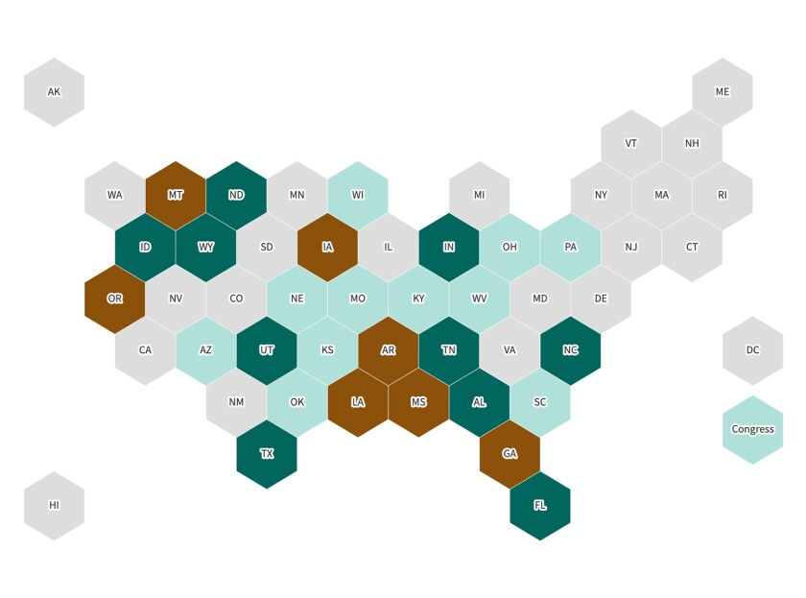
Explore maps, read descriptions, and check the status of bills in states where lawmakers are seeking to restrict colleges’ DEI efforts.
Visit The Assault on DEI for related stories.
The university declined to confirm how many or which jobs were being cut.
The state Senate’s Committee on Education plans to conduct a hearing next month at which chancellors and general counsels at public colleges across the state will be asked to describe their compliance efforts, according to Creighton. He said that, while he was encouraged by the progress made on some campuses, he worried “that many institutions may choose to merely rename their offices or employee titles.” (UT’s Division of Campus and Community Engagement was previously known as the Division of Diversity and Community Engagement, one of dozens of name changes that took place statewide after SB 17 was signed into law.)
Colleges that violate the law, Creighton warned, could have their funding frozen and face legal ramifications.
ADVERTISEMENT
Hartzell wrote in his email on Tuesday that the university had been examining its programs to ensure that they complied with SB 17 by the date it took effect, January 1, “but we knew that more work would be required to utilize our talent and resources most effectively in support of our teaching and research missions and, ultimately, our students.”
In January the flagship closed its 20-year-old Gender and Sexuality Center and opened the Women’s Community Center in the same space, with the same staff.
“Our mission is to be a place for Longhorns of all genders to connect, find resources, and get support around experiences of intersection,” the center announced in an Instagram post at the time.
The center said that, to comply with SB 17, which bans diversity, equity, and inclusion programs at Texas’ public colleges, it was eliminating all training and workshops related to race, sexual orientation, and gender identity. That included training for people seeking to be designated as allies.
In addition to the three full-time positions that are being eliminated in the women’s center, a shared administrative position was cut, according to the source who spoke with The Chronicle.
ADVERTISEMENT
The center’s rebranding raised concerns that LGBTQ students might not know the program was there, in part, to support them, and that it might also alienate students who don’t identify as women.
Critics have complained that the university is over-complying with the anti-DEI law, eliminating programs that would have withstood legal scrutiny to avoid the danger of losing funding. Also among the recent cuts, the university closed its multicultural-engagement center and ended a scholarship program for undocumented students. On Tuesday, Brandelyn Franks Flunter, the multicultural center’s director, posted a message on Facebook saying she was among those being fired.

Read other items in this The Assault on DEI package.

DIVERSITY, EQUITY, & INCLUSIONLAW & POLICY
Katherine Mangan
Katherine Mangan writes about community colleges, completion efforts, student success, and job training, as well as free speech and other topics in daily news. Follow her @KatherineMangan, or email her at katherine.mangan@chronicle.com.

